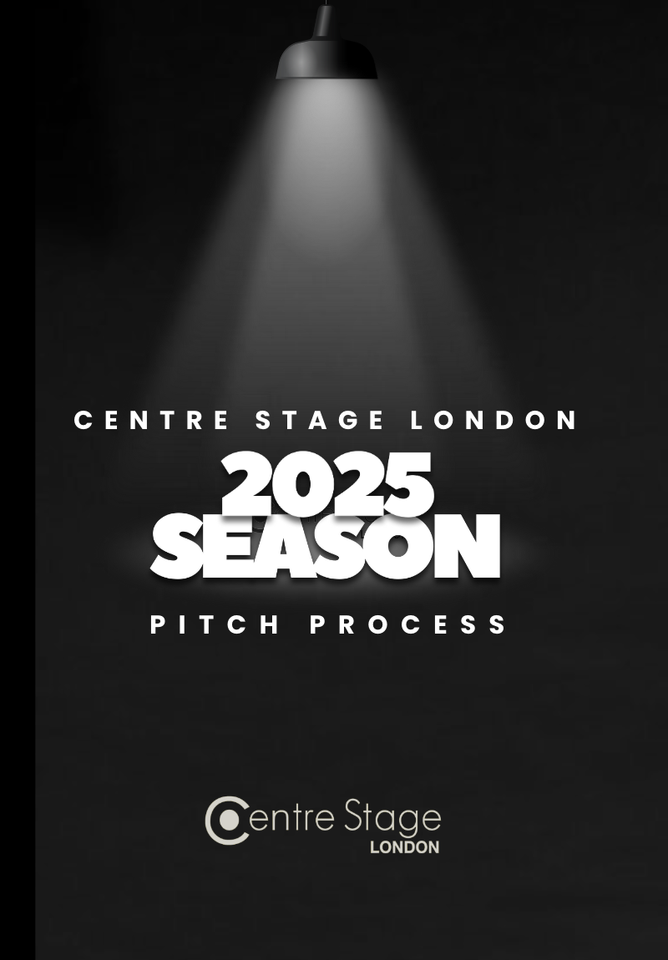

INTRODUCTION

Individuality. Diversity. Uniqueness. Community. At Centre Stage London we celebrate that which makes our shows so unique: you.

Our membership, and its diversity, makes our shows successful and reflects the vibrant community that we serve. It is our differences - be it age, gender identity, sexual orientation, ethnicity, disability - that make us what we are, and they are the foundations of Centre Stage London.

Bring your true self; it is why we love you.

 | Audition Dates | Rehearsal Period | Show Week
Spring Show 2025 | First rounds:  w/c 18th November  Recalls:  w/c 25th November | First rehearsal:  7th January 2025  Last rehearsal:  29th March 2025 | Get-In 30th March 2025  Dress 31st March 2025  Performances 1st – 5th April 2025
Summer Show 2025 (2 week slot) | First rounds:  w/c 7th April 2025  Recalls:  w/c 14th April 2025 | First rehearsal:  26th April 2025  Last rehearsal:  12th July 2025 | Get-In 13th July 2025  Dress 15th July 2025  Performances 16th-25th July 2025
Winter Show 2025 | First rounds:  w/c 28th July 2025  Recalls:  w/c 4th August 2025 | First rehearsal:  8th September 2025  Last rehearsal:  29th November 2025 | Get-In 30th November 2025  Dress 1st December 2025  Performances 2nd-6th December 2025
We have secured dates at the Bridewell Theatre (a 135 seat venue) for 2024 in February, July and November. Each Bridewell show will have a 11-12 week rehearsal period that does not overlap with the other shows. To help you visualize, the table below gives an idea of production timelines.

The form has 4 sections and is intended for multiple uses. Please read the accompanying guidelines document in full for guidance. We know the form is long – just do your best to fill in as much as you can, so we can get the best understanding of your ideas. Don’t panic if there are gaps, as if you are shortlisted you will get the opportunity to discuss with us.

The pitch process is inviting submissions of musicals, cabarets and plays. Depending on pitches received we may not finish up with a season that includes a play, but we are open to ideas which widen our audience appeal, and so invite pitches for plays as well as musicals and cabarets.
You only need to fill in what is necessary for your level of interest:
- If you are suggesting a show please just send us an email (secretary@centrestage.london)
- If you are volunteering to be on a creative team for 2025 but are not pitching a specific show, please fill out parts 1 & 3 (CONTACT DETAILS and WHO’S WHO)
- If you are pitching a show - with or without a full production team, but with yourself filling a key role - please fill out all sections (CONTACT DETAILS, ABOUT THE SHOW, WHO’S WHO and YOUR PRODUCTION) plus the Budget form which you can download from our website.
Please send your completed form, (with the budget form if you are pitching a show), to secretary@centrestage.london with the subject heading “2025 Pitch Process” by 31st May 2024 at the latest to be considered for the 2025 season.
We can’t wait to hear from you,
The Trustees

PART 1 – CONTACT DETAILS

Let us know who you are and how we can get in contact with you (everyone should fill this in)

1.1 Your Name

1.2 Your email

1.3 Your pronouns (there is no demand for disclosure)

1.4 Your telephone number

1.5 Are you volunteering or pitching?

PART 2 – ABOUT THE SHOW

Tell us about the show you would like to pitch

IS THIS A PLAY, A MUSICAL OR A CABARET?

2.1 NAME OF PLAY/MUSICAL/CABARET Include writer, composer and other useful information if relatively unknown. If there is more than one version, let us know which version.

2.2 SHOW SYNOPSIS/CABARET THEME – just a brief explanation will do

2.3 SETTING – what period it is set in, locations and style (e.g. 1930’s, America, set in posh house and grand party)

CABARETS – if a cabaret are you looking to set it in a particular environment (e.g. jazz café style, burlesque, music hall etc.)

2.4 SONG LIST – indicate if a solo, duet, etc or a full ensemble, also which numbers are likely to have choreography.

CABARETS – If a cabaret let us know the proposed songs or a few numbers that give us an idea of the type of songs to expect – it doesn’t have to be the full set list!

PLAYS- Not Applicable

2.5 CAST SIZE – How many in total and the split between male and female voice types

2.6 CAST LIST - Indicate character sex, age range (playing age!), character type (serious elder daughter, upbeat comedy uncle, ditzy blonde who always falls for the wrong guy…)

CABARETS – let us know the approximate split between solos, small groups (duets, quartets) and big ensemble numbers

2.7 MUSIC – a rough description of how big the band might be, type of music (rock, pop, orchestral, jazz, choral)

PLAYS- Please list any music used. Will it be live or pre-recorded? Do you need help obtaining pre-recorded music?

2.8 Why do you think this is the right show for Centre Stage?

2.9 Sell us your show! If your production is a well-known title, please describe how your production will be special and different from previous productions. Why would audiences want to come and see your production? Imagine you’re advertising your show and have some fun with this section!

PART 3 – WHO’S WHO?

Tell us about the team you have, or if you are volunteering to be a part of a team just tell us about yourself (If you are pitching you don’t need to have the full team but please tell us who you do have on board so we can understand the gaps which we can help you fill)

CREATIVE TEAM – please let us know who is on-board or where you would like to be a part. If you are pitching a show for a particular slot(s) and you haven’t got a full team, let us know who you have so far.
Director
Name
Contact Telephone number
Email address
Brief biography (include relevant experience)
Referee (please enter details if you haven’t worked with Centre Stage before)
Musical Director
Name
Contact Telephone number
Email address
Brief biography (include relevant experience)
Referee (please enter details if you haven’t worked with Centre Stage before)
Choreographer
Name
Contact Telephone number
Email address
Biography (include relevant experience)
Referee (please enter details if you haven’t worked with Centre Stage before)
Producer
Name
Contact Telephone number
Email address
Biography (include relevant experience)
Referee(please enter details if you haven’t worked with Centre Stage before)
Assistant Musical Director
Name
Contact Telephone number
Email address
Biography (include relevant experience)
Referee (please enter details if you haven’t worked with Centre Stage before)
Assistant Choreographer
Name
Contact Telephone number
Email address
Biography (include relevant experience)
Referee(please enter details if you haven’t worked with Centre Stage before)

TECHNICAL TEAM – if you have people on-board for this then fill in the details here. If you don’t, please move on to the next section
Stage Manager
Name
Contact Telephone number
Email address
Biography (include relevant experience)
Referee (please enter details if you haven’t worked with Centre Stage before)
Deputy Stage Manager/Assistant Stage Manager
Name
Contact Telephone number
Email address
Biography (include relevant experience)
Referee (please enter details if you haven’t worked with Centre Stage before)
Set Design/Construction
Name
Contact Telephone number
Email address
Biography (include relevant experience)
Referee (please enter details if you haven’t worked with Centre Stage before)
Costume Design/Creation
Name
Contact Telephone number
Email address
Biography (include relevant training and experience)
Referee(please enter details if you haven’t worked with Centre Stage before)
Lighting Designer
Name
Contact Telephone number
Email address
Biography (include relevant experience)
Referee(please enter details if you haven’t worked with Centre Stage before)
Props Manager
Name
Contact Telephone number
Email address
Biography (include relevant experience)
Referee(please enter details if you haven’t worked with Centre Stage before)
Graphic Designer
Name
Contact Telephone number
Email address
Biography (include relevant experience)
Referee(please enter details if you haven’t worked with Centre Stage before)
Photography
Name
Contact Telephone number
Email address
Biography (include relevant experience)
Referee(please enter details if you haven’t worked with Centre Stage before)

TECHNICAL TEAM – If you would like us to book our regular Photography, Graphic Designer, Sound and Lighting Teams, please tick below (Please note, budgets for these are listed as example budgets lines in the Budget Form which accompanies this)
Photography (Costumed promotional photos for social media release, headshot photography and dress rehearsal photography) | □
Graphic Design (Show logo, poster, photography editing, social media assets, programme designer) | □
Lighting Designer | □
Sound Designer | □

PART 4 – YOUR PRODUCTION

This section is for shows or cabarets that are pitching for a particular slot in our calendar. This is where you can tell us about how you will put on your production, what it will look like and all the technical considerations we will need to consider. This is your chance to sell your concept and ideas, bring the show to life and to get us excited.

Cabarets – we aim to put on simple cabarets, limited lighting and costumes but please answer anything in this section to let us know how it will look. The budgets are a lot smaller for cabarets but just because it is not on at the Bridewell, it doesn’t mean you have to limit your imagination.

4.1 PROPOSED DATE OF SHOW/CABARET
Bridewell Show – Please provide an order of preference for the available Bridewell slots (please read the accompanying guideline document carefully for details, which includes when auditions would take place, the rehearsal period, and the show week)
Delete as appropriate

Bridewell Show:
I am proposing a show for one of the confirmed Bridewell slots – YES/NO
My order of preference is : (please order the available slots in your order of preference – the dates for these are in the Guidelines document.)
1.
2.
3.
Are any of these slots completely unworkable for you? If so, please state.

4.2 ARE RIGHTS AVAILABLE FOR THIS SHOW? – It is notoriously difficult to get the rights for shows in Central London, there are a lot of shows we just can’t do because they’re currently on the West End or currently touring around the UK/IE.

If you don’t know how to enquire we can do that for you, but if you have already checked and know, please let us know here

4.3 WHO ARE THE RIGHTS HOLDERS? E.g. Concord Theatricals, Music Theatre International etc.

4.4 HOW WOULD YOU STAGE THE SHOW/CABARET? Unleash your imagination…What will your set look like, how will the production look on stage? Will there be a lot of scene changes and how will this work? Is there a big set piece that will be the main focus? What is the overall style? What furniture will be needed? What entrances and exits are needed? Paint us a picture of what the stage will look like through the show.

If intending to perform at The Bridwell Theatre, please indicate how your production will adapt the confines of this venue (if you’re not sure what these are, please contact us to ask and discuss).

CABARETS – we encourage cabarets to be simple and require limited staging but please let us know if you want any particular setting, backdrops, decorations etc.

4.5 DIVERSITY & INCLUSION AT CENTRE STAGE
We ask you to take the time to read the London Drama Societies policies on ‘Casting and Authentic Storytelling’ and ‘Marketing’, before pitching, and use this section to please describe how your production will adhere to these policies. www.londondramasocieties.co.uk/home/resources

In this section, please be specific.

4.6 SPECIAL TECHNICAL CONSIDERATIONS – Are there any special technical considerations that have to be included e.g. a crucifixion, hanging a person, magic tricks, roller skating, projection etc. How do you intend to achieve these? If you are not sure how to deal with it just let us know, our Artistic Director is able to help.

4.7 COSTUMES/WIGS/MAKE UP – What costumes are needed? Are they period costumes, special costumes, modern day, business suits, mythical etc? How many costumes will you think you will need? Do the principals have a number of costume changes, how many and into what, or do they stay in the same outfit throughout? Do the ensemble have changes and if so how many? Are they full changes or is it just a small change? Any technical issues, such as special shoes, wigs or make up?

4.8 LIGHTING – How will it be lit? Are you looking for a big lighting spectacle, natural lighting, a rock show? Is there a feel you will be looking to create e.g. in a wooded glade, in space, disco, at sea etc? Do you want spotlights? Is there any lighting special effects e.g. projection, gobos, strobe, blacklight, star cloth, smoke, haze etc?

4.9 BAND – How big is it?! How many band members are needed? What instruments are listed on the score? Are there any special instruments/requirements e.g. three specific synthesizers?

4.10 SOUND – Please let us know in this section if there are any special requirements e.g sound effects, off stage singing, on stage hand-held microphones etc.

4.11 INCOME – We know budgets are tight and we have to budget effectively, this does have an impact on shows. Unfortunately ticket sales alone do not cover the cost of a show and we will work with you on fundraising ideas to support the show. However, if you know of any specific donations you could rely on or have any fundraising ideas that could help supplement your production, please let us know here.

NOTE - BUDGET
Centre Stage is a registered charity and as such, we budget all our shows to ensure that they pay for themselves. We do not pay for the creative team nor actors, however we do pay a small amount to band members, and to vendors such as lighting and sound. Budgets must include the cost of rehearsal space, but we will negotiate and arrange this for you. Please fill out the budget form to the best of your availability and include it with your submission. If you are successful, we will refine this with you, so please don’t panic about it, just have a stab!
Our Treasurer will work with your Producer to agree a full show budget that will detail all costs if you are successful.
I confirm I have included a budget form [ ]

